LAMBTON COLLEGE



**A Report on**

[**Lab 4,5,6 on** [**AWS Academy Data Analytics**](https://moodle.queenscollege.ca/moodle/mod/lesson/view.php?id=436567)**]**

121 Brunel Rd, Mississauga

ON L4Z 3E9

A Group assignment with screenshots of Lab 4, 5, and 6

on Aws academy

Big Data Analytics DSMM

**Under the supervision**

**of**

**Professor Teresa Zhu**

**Submitted BY:**

Aadarsha Chapagain (C0825975)

Roshan Acharya (C0831342)

Anjana Kuriakose (C0829580)

Onyinye Mbanefo (C0831578)

**Submitted To:**

Lambton College

Professor Teresa Zhu

**Submission Date:**

27th  November 2022

# Lab4: Analyze Data with Amazon Redshift

## Task 1: Task 1: Review the security group for accessing the Amazon Redshift console

Myredshiftrole

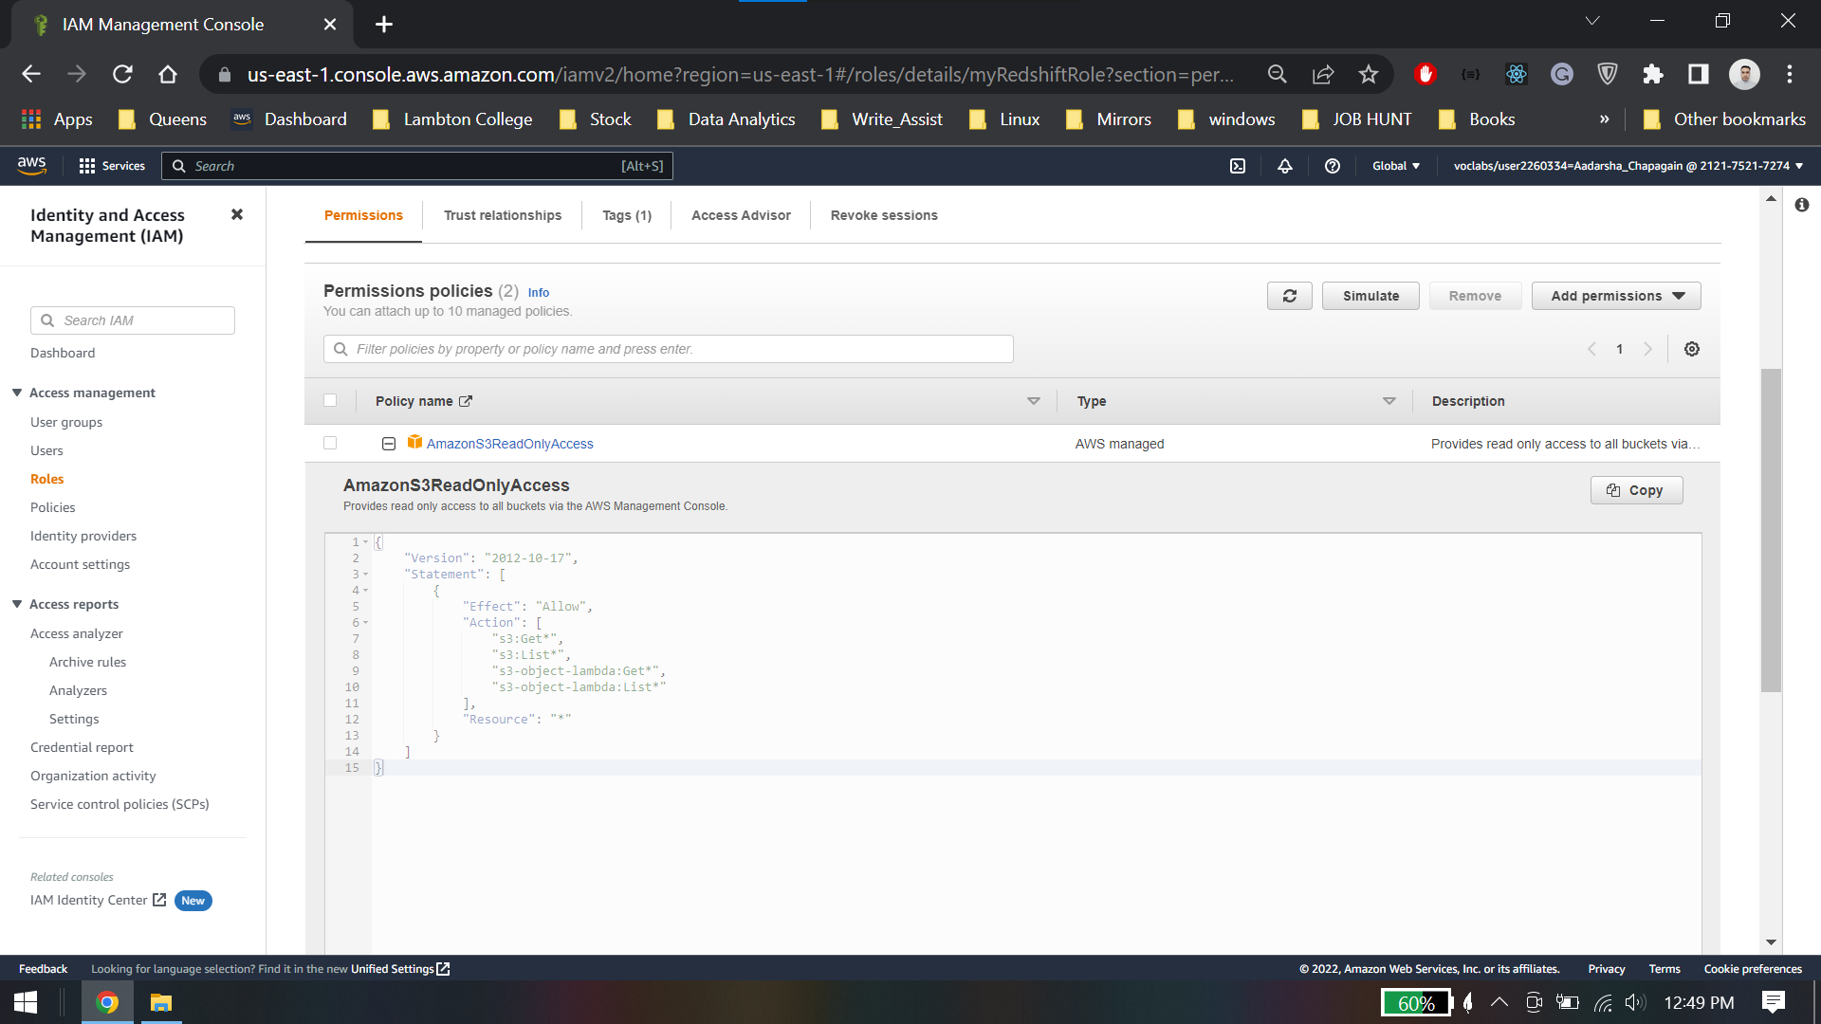

## Task 2: Create and configure an Amazon Redshift cluster

### Task 2.1: Create a security group for your cluster

### Task 2.2: Configure your Amazon Redshift cluster

## Task 3: Load data into your Amazon Redshift cluster

### Task 3.1: Create the tables in the dev database

User table:

Date table

Sales table

### Task 3.2: Load data from Amazon S3

arn:aws:iam::212175217274:role/myRedshiftRole

Copy users table

Copy date table

Copy sales table

## Task 4: Query the data

Preview sales table

Number of item sold on particular date

Top 10 buyers by quantity

## Lab 4 Conclusion.

* Accessed Amazon Redshift in the AWS Management Console
* Created an Amazon Redshift cluster.
* Load data from Amazon Simple Storage Service (Amazon S3) into an Amazon Redshift table
* Queried data in Amazon Redshift

# Lab5: Analyze Data with Amazon Sagemaker, Jupyter Notebooks and Bokeh

## Task 1: Obtain the AWS Identity and Access Management (IAM) role

Sagemakerrolearn: arn:aws:iam::692496158592:role/sagemakerlab

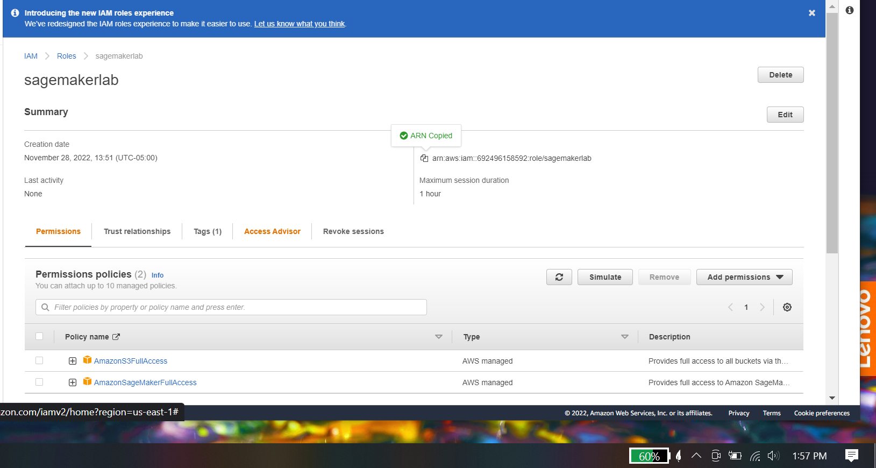

## Task 2: Create a Jupyter notebook with Amazon SageMaker

## Task 3: Open your Jupyter notebook instance

## Task 4: Create visualizations with Bokeh

### Task 4.1: Create a line graph

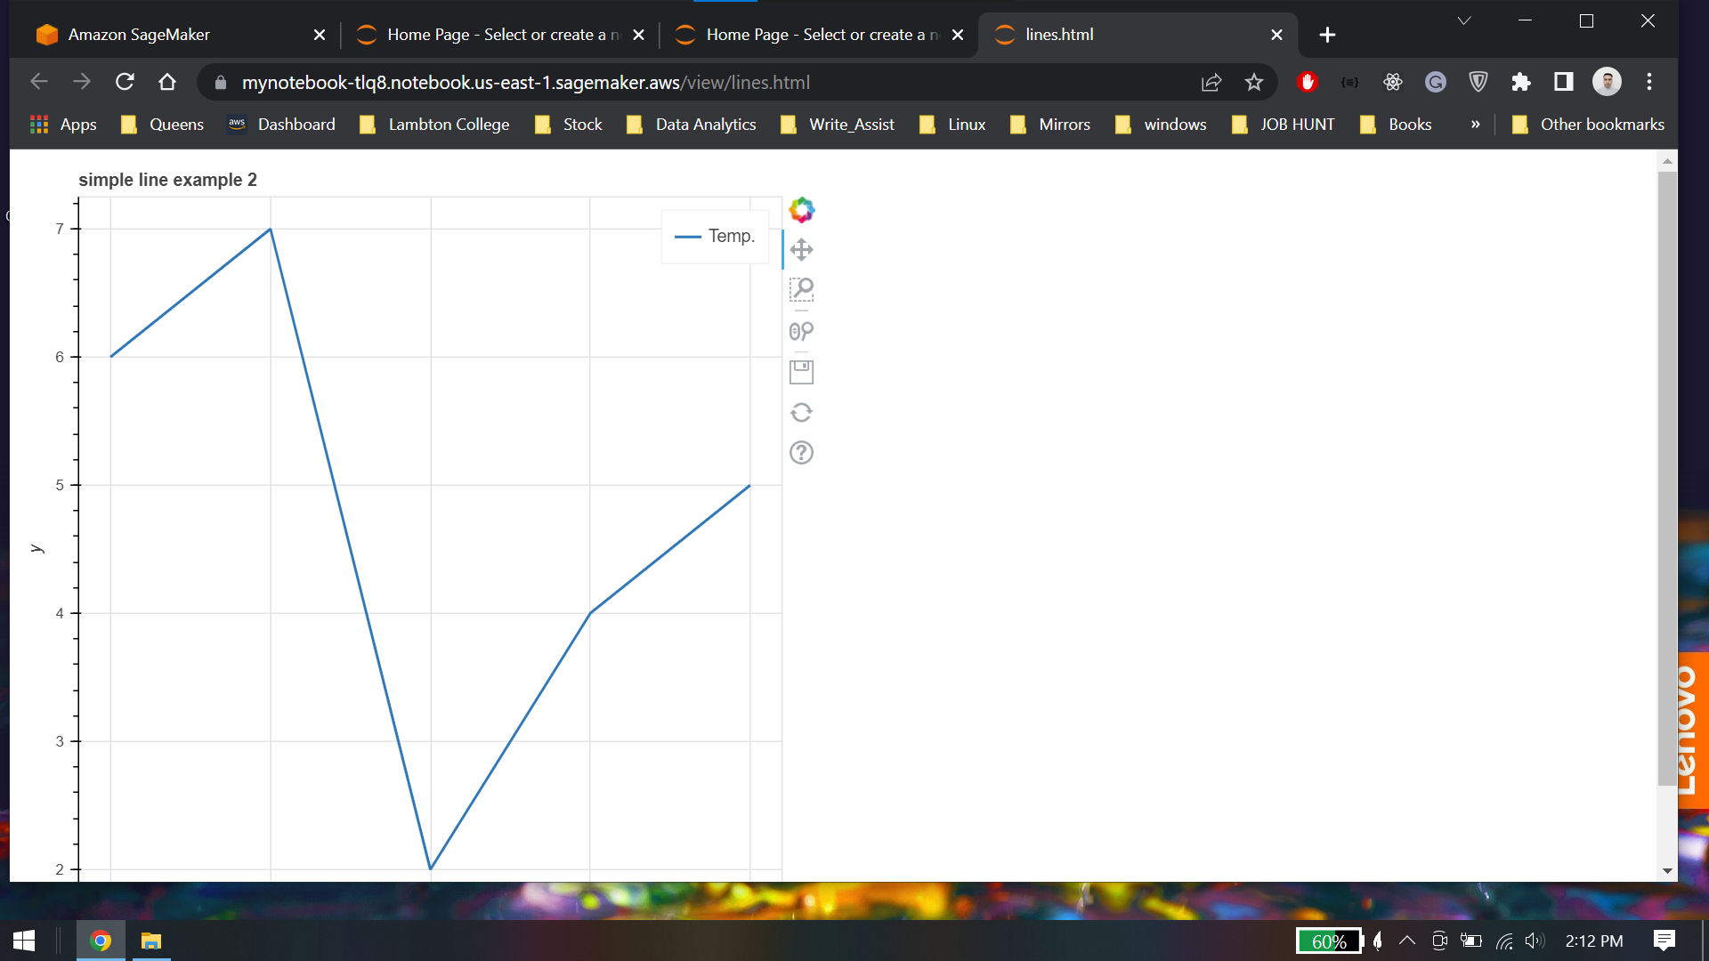

### Task 4.2: Create a bar chart

### Task 4.3: Create a grouped bar chart

## Task 5: Create a visualization from a dataset

### Task 5.1: Download the data file

### Task 5.2: Create the notebook

## Lab 5 Conclusion

* Described Jupyter notebooks and the Bokeh visualization package.
* Created a Jupyter notebook with Amazon SageMaker.
* Imported data into a Jupyter notebook.
* Created a presentation with a Jupyter notebook.
* Visualized data with the open-source Bokeh Python package.

# Lab 6: Automate Loading Data with AWS Data Pipeline

## Task 1: Review the security group for accessing the Amazon Redshift console

Arn: arn:aws:iam::802857576737:role/myRedshiftRole

## Task 2: Create and configure an Amazon Redshift cluster

Create subnet cluster group

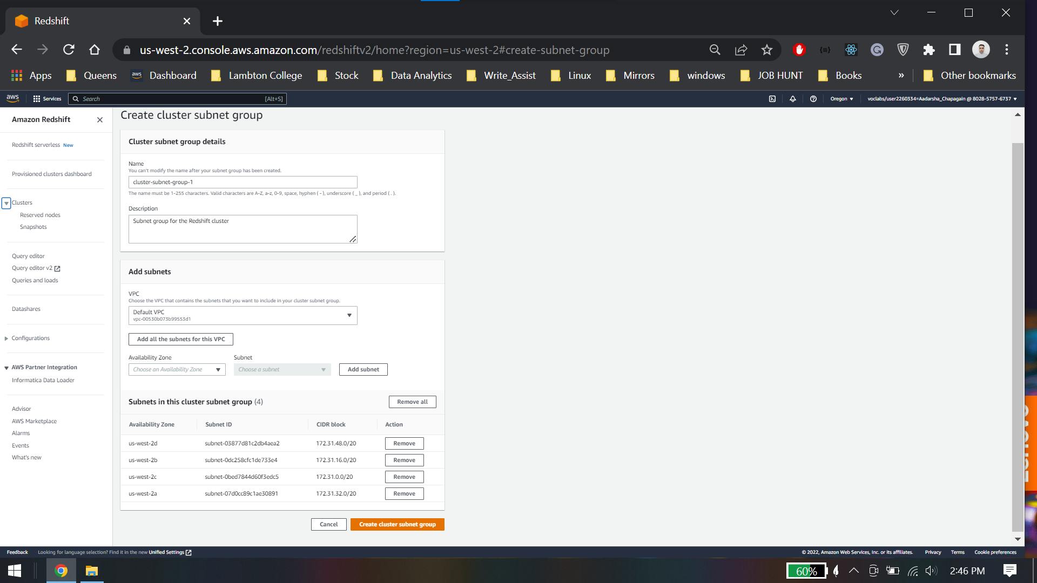

Create cluster

### Task 2.1: Create a security group for your cluster

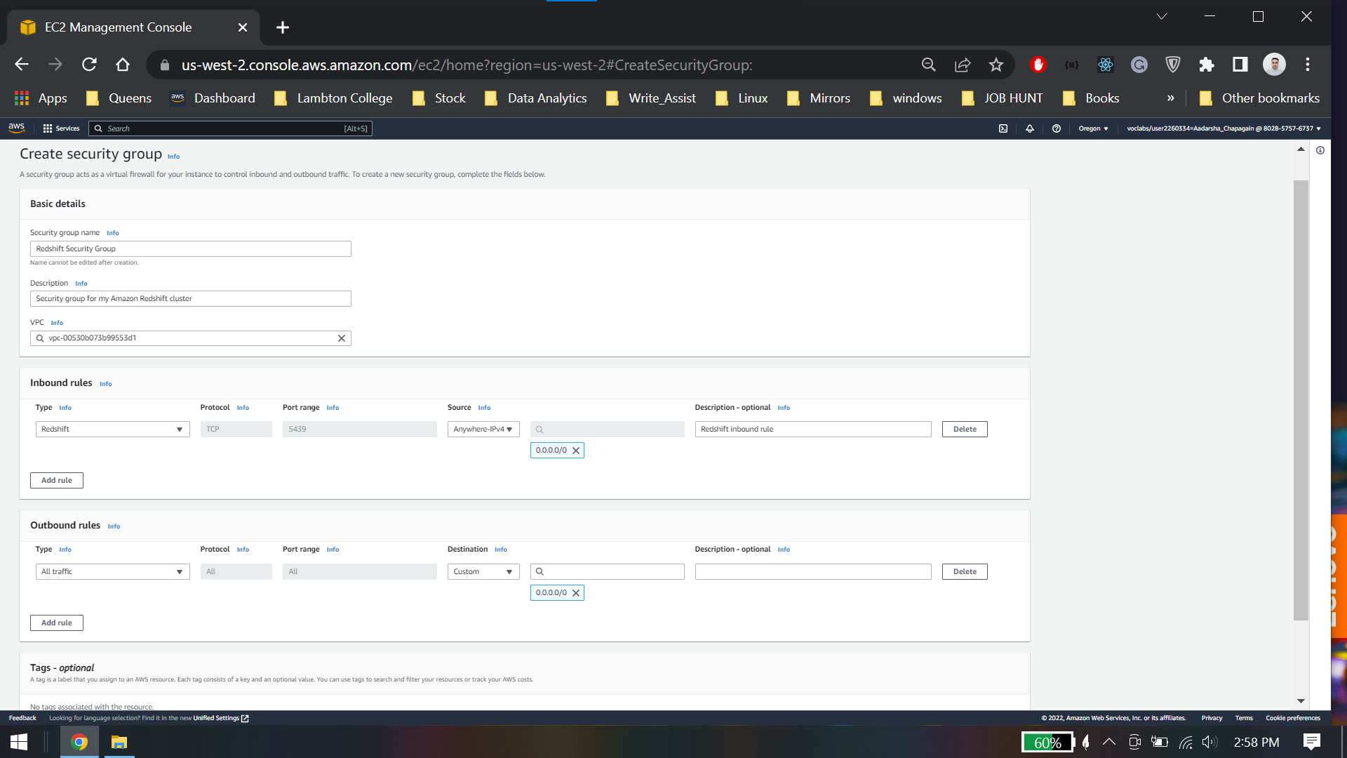

### Task 2.2: Configure your Amazon Redshift cluster

### Task 2.3: Capture JDBC connection information

### Task 2.4: Create an S3 bucket to store log files

Bucketname:logbucketgroupa

Jdbc Connection: jdbc:redshift://redshift-cluster-1.c9howuam5uab.us-west-2.redshift.amazonaws.com:5439/dev

## Task 3: Create the pipeline

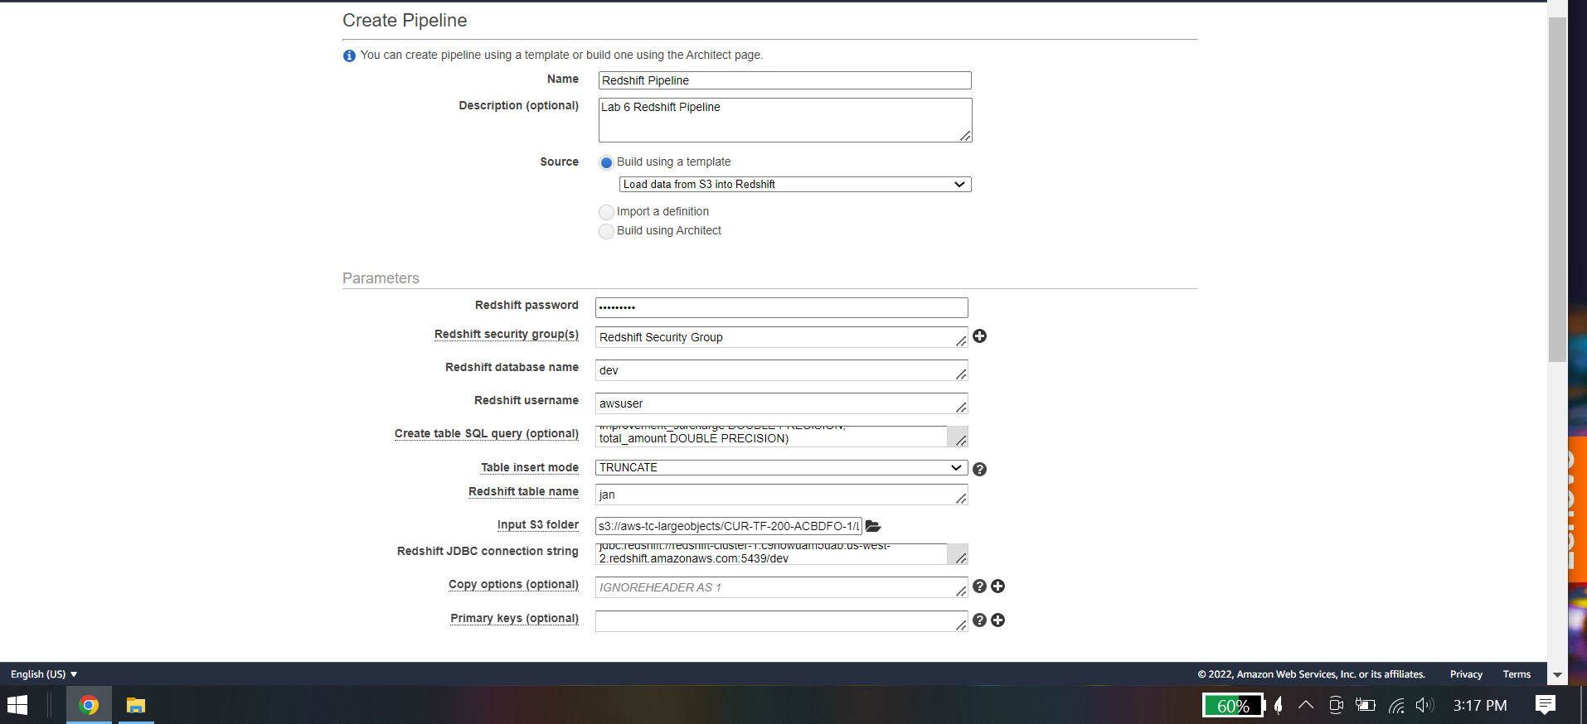

## Task 4: Monitor your pipeline

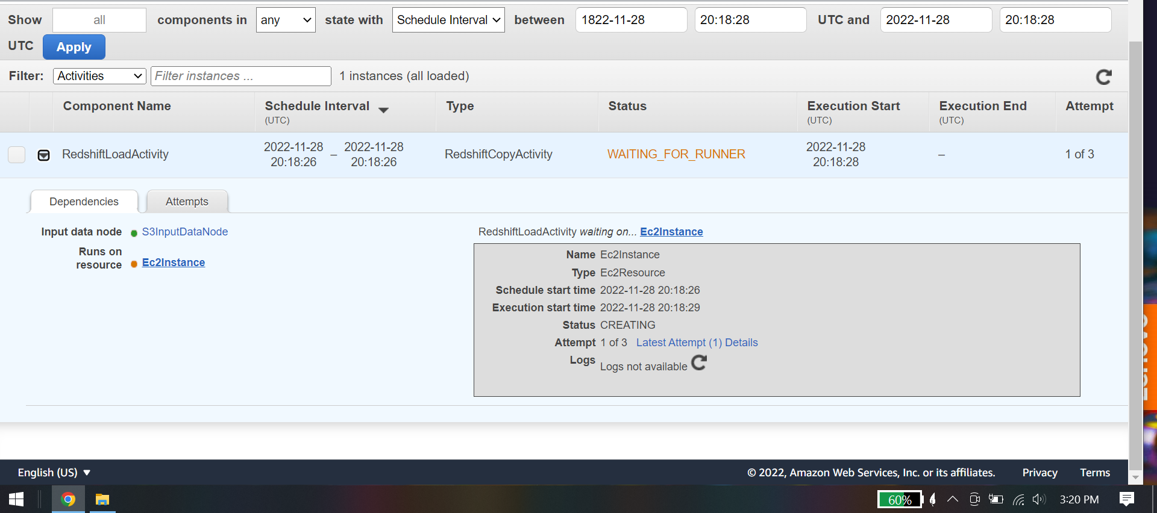

## Task 5: View log files

## Task 6: Query the Amazon Redshift database

Connect to redshift using username and password

## Lab 6 Conclusion

* Accessed AWS Data Pipeline in the AWS Management Console.
* Created a data pipeline.
* Load data from Amazon S3 into Amazon Redshift with a data pipeline.
* Troubleshoot a data pipeline.
* Export data from Amazon Redshift to a Jupyter notebook